

My Target: ____ / 50 or ______ % Complete on the day of the test

🖒 🖓 (Circle when your assignment is handed back)

|  |  |  |
| --- | --- | --- |
| Total marks  **50** | **%** | **Weight**  **3.5%** |
|  |  |  |

**Name: ________________________________________**

**Teacher: ______________________________________**

Year 9 Humanities & Social Sciences: *Civics & Citizenship*

***Assessment 7 – Key Features of Australia’s Court System***

**PART A:** GRAPHIC ORGANISER ASSESSMENT 3.5%

**PART B:** VALIDATION 4.0%

**Part A: You will have 2 lessons in class to complete this task.**

**Complete** a graphic organiser using the A3 paper supplied. The Graphic Organiser will be used to show the hierarchy of Australia’s Court System and to complete an in-class validation assessment. It is based on the example layout shown on the reverse side of this page. Information provided in **Source One** will need to be organised to complete your graphic organiser. It is important that the graphic organiser only includes a concise description of the Australian Court System. You should use the information provided and omit any unnecessary information so that only the key points are included. Focus the information on the role and types of cases heard in the corresponding court. Code the role and types of cases using **2 different colours.**

**Part B: In-class validation under timed, test conditions.**

Complete the following tasks on the checklist below:

|  |  |  |
| --- | --- | --- |
| **Task** | **Marks Allocation** | **Checklist**  **✔** |
| Title of the Graphic Organiser | 1 |  |
| Label each court for both the State and Federal Court Systems | 7 |  |
| Describe the role of the court (what is its function in the court system) | 7 |  |
| State the types of cases heard in the court (at least 2 per court) | 14 |  |
| State whether a Judge and/or Jury is used (as well as the number of these) | 7 |  |
| Label the arrows | 8 |  |
| Colour used to code the roles and types of cases | 7 |  |
| Overall neatness and presentation | 1 |  |

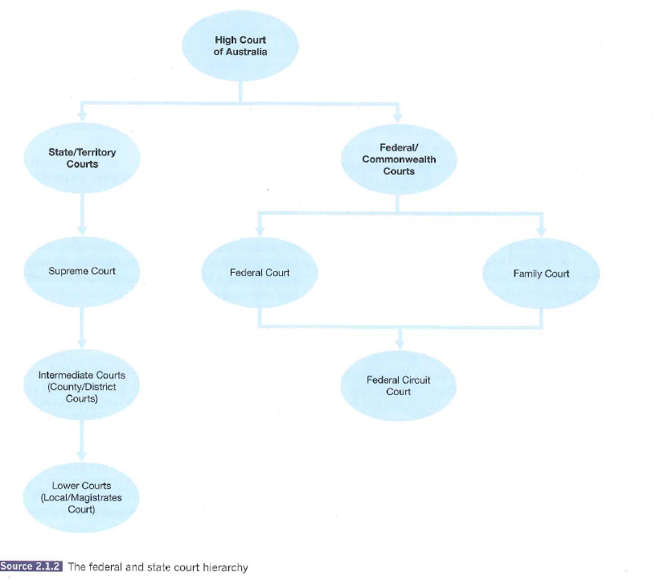**EXAMPLE LAYOUT**